Miraji Mlilingwa

Dec 6, 2017

CSc 4710

Database Project

CREATE TABLE tbl_customer(

   customer_id INT(11)  AUTO_INCREMENT,

   first_name VARCHAR(45) NOT NULL,

   last_name VARCHAR(45) NOT NULL,

   telephone VARCHAR(45) NOT NULL,

   email VARCHAR(45),

   address VARCHAR(255),

   city VARCHAR(45),

   state VARCHAR(45),

   zip_code VARCHAR(45),

   PRIMARY KEY (customer_id)

   );

   CREATE TABLE tbl_vehicle(

   vehicle_id INT(11)  AUTO_INCREMENT,

   VIN VARCHAR(45),

   year  YEAR  NOT NULL,

   make VARCHAR(45) NOT NULL,

   model VARCHAR(45) NOT NULL,

   mileage INT(11) NOT NULL,

   PRIMARY KEY (vehicle_id)

   );

   CREATE TABLE tbl_order(

   order_id INT(11)  AUTO_INCREMENT,

   start_time  datetime NOT NULL,

   end_time  datetime  NOT NULL,

   PRIMARY KEY (order_id)

   );

   CREATE TABLE tbl_service(

   service_id INT(11)  AUTO_INCREMENT,

   name VARCHAR(255) NOT NULL,

   labor_hour DOUBLE NOT NULL,

   part_cost DOUBLE NOT NULL,

   rate_id INT(11) NOT NULL,

   PRIMARY KEY (service_id),

   FOREIGN KEY (rate_id) REFERENCES tbl_rate(rate_id)

   );

CREATE TABLE tbl_rate(

   rate_id INT(11) AUTO_INCREMENT,

   labor_cost_per_hour DOUBLE NOT NULL,

   PRIMARY KEY (rate_id)

   );

   CREATE TABLE tbl_customer_vehicle(

   customer_vehicle_id INT(11) AUTO_INCREMENT,

  customer_id INT(11) NOT NULL,

  vehicle_id INT(11) NOT NULL,

   PRIMARY KEY (customer_vehicle_id),

   FOREIGN KEY (customer_id) REFERENCES tbl_customer(customer_id),

   FOREIGN KEY(vehicle_id) REFERENCES tbl_vehicle(vehicle_id)

   );

    CREATE TABLE tbl_vehicle_order(

   vehicle_order_id INT(11) AUTO_INCREMENT,

  vehicle_id INT(11) NOT NULL,

  order_id INT(11) NOT NULL,

   PRIMARY KEY (vehicle_order_id),

   FOREIGN KEY (vehicle_id) REFERENCES tbl_vehicle(vehicle_id),

   FOREIGN KEY(order_id) REFERENCES tbl_order(order_id)

   );

   CREATE TABLE tbl_order_service(

   order_service_id INT(11) AUTO_INCREMENT,

  order_id INT(11) NOT NULL,

  service_id INT(11) NOT NULL,

   PRIMARY KEY (order_service_id),

   FOREIGN KEY (order_id) REFERENCES tbl_order(order_id),

   FOREIGN KEY(service_id) REFERENCES tbl_service(service_id)

   );

INSERTING DATA

INSERT INTO `tbl_customer` (`customer_id`, `first_name`, `last_name`, `telephone`, `email`, `address`, `city`, `state`, `zipcode`) VALUES  
(1, 'Uma', 'Kline', '1-753-492-2603', '[tempor@nislelementumpurus.ca](mailto:tempor@nislelementumpurus.ca)', '3092 Mus. Road', 'Troy', 'AL', '36082'),  
(2, 'Madeson', 'Peck', '[1-947-343-1784](tel:(947)%20343-1784)', '[amet@purusactellus.ca](mailto:amet@purusactellus.ca)', '964 Eleifend Road', 'Troy', 'AL', '36082'),  
(3, 'Audra', 'Green', '[1-947-428-7998](tel:(947)%20428-7998)', 'vitae@Vivamusmolestie.net', 'Ap #990-6604 Penatibus Avenue', 'Troy', 'AL', '36081'),  
(4, 'Aspen', 'Beach', '1-411-573-2065', 'magna@dolorFusce.com', 'P.O. Box 952, 2633 Vitae, Rd.', 'Troy', 'AL', '36081'),  
(5, 'Aladdin', 'Benton', '1-727-147-6363', '[Sed.eu.nibh@pharetrased.org](mailto:Sed.eu.nibh@pharetrased.org)', '6312 Ipsum Ave', 'Troy', 'AL', '36081'),  
(6, 'Brittany', 'Montgomery', '1-467-615-4861', 'vulputate@liberoProinmi.net', '1621 Ut Rd.', 'Dunwoody', 'GA', '30338'),  
(7, 'Anjolie', 'Heath', '1-536-706-1713', '[nisi.sem.semper@purusin.co.uk](mailto:nisi.sem.semper@purusin.co.uk)', '6077 Mauris, St.', 'Dunwoody', 'GA', '30338'),  
(8, 'Hyatt', 'Park', '1-948-606-8053', 'pede.blandit@acorciUt.ca', 'Ap #903-1473 Dui. Rd.', 'Dunwoody', 'GA', '30338'),  
(9, 'Lila', 'Wilder', '1-245-273-9998', 'nunc.In@nisiMauris.com', '681-2452 Rhoncus. Rd.', 'Dunwoody', 'GA', '30338'),  
(10, 'Quyn', 'Solomon', '1-383-861-4902', '[risus@ultricies.org](mailto:risus@ultricies.org)', '9619 Sed Av.', 'Destin', 'FL', '11111'),  
(11, 'Chadwick', 'Bradley', '1-478-171-5482', 'non.lacinia@Integereu.net', '1245 Id Ave', 'Destin', 'FL', '11111'),  
(12, 'Yoko', 'Medina', '[1-434-908-2900](tel:(434)%20908-2900)', 'ullamcorper.Duis.at@sapienNuncpulvinar.ca', 'P.O. Box 739 9593 Sed, St.', 'Destin', 'FL', '11111'),  
(13, 'Scarlet', 'Mcdowell', '1-146-378-6864', 'gravida@IntegerurnaVivamus.ca', '434-3833 Massa. St.', 'Destin', 'FL', '11111'),  
(14, 'Ora', 'Huber', '[1-360-264-3481](tel:(360)%20264-3481)', '[erat.volutpat.Nulla@nulla.ca](mailto:erat.volutpat.Nulla@nulla.ca)', 'P.O. Box 270, 9403 Dolor Road', 'Destin', 'FL', '11111'),  
(15, 'Hedy', 'Horton', '[1-949-615-7909](tel:(949)%20615-7909)', '[penatibus.et.magnis@posuerecubilia.org](mailto:penatibus.et.magnis@posuerecubilia.org)', '8165 Feugiat. Rd.', 'Destin', 'FL', '11111'),  
(16, 'Orla', 'Pitts', '[1-681-542-2665](tel:(681)%20542-2665)', '[vulputate@ornare.net](mailto:vulputate@ornare.net)', 'Ap #677-909 Tincidunt St.', 'Atlanta', 'GA', '30303'),  
(17, 'Melyssa', 'Massey', '[1-418-698-0427](tel:(418)%20698-0427)', '[tellus.Suspendisse@blandit.edu](mailto:tellus.Suspendisse@blandit.edu)', '492-6689 Laoreet, Road', 'Atlanta', 'GA', '30303'),  
(18, 'Yvette', 'Bartlett', '1-164-115-9068', 'facilisis@Morbi.ca', 'Ap #910-4141 Ligula. Road', 'Atlanta', 'GA', '30303'),  
(19, 'Kiara', 'Shields', '1-542-337-1106', '[massa.Vestibulum@rutrumFusce.co.uk](mailto:massa.Vestibulum@rutrumFusce.co.uk)', '6868 Integer St.', 'Atlanta', 'GA', '30303'),  
(20, 'Leigh', 'Williams', '[1-917-657-0658](tel:(917)%20657-0658)', '[blandit.at@anequeNullam.co.uk](mailto:blandit.at@anequeNullam.co.uk)', '310-184 Mi Av.', 'Atlanta', 'GA', '30303');

INSERT INTO `tbl_order` (`order_id`, `start_time`, `end_time`) VALUES

(1, '2014-02-01 08:00:00', '2014-02-02 08:00:00'),

(2, '2014-02-02 08:00:00', '2014-02-03 08:00:00'),

(3, '2014-02-03 08:00:00', '2014-02-04 08:00:00'),

(4, '2014-02-04 08:00:00', '2014-02-05 08:00:00'),

(5, '2014-02-05 08:00:00', '2014-02-06 08:00:00'),

(6, '2014-02-06 08:00:00', '2014-02-07 08:00:00'),

(7, '2014-02-07 08:00:00', '2014-02-08 08:00:00'),

(8, '2014-02-08 08:00:00', '2014-02-09 08:00:00'),

(9, '2014-02-09 08:00:00', '2014-02-10 08:00:00'),

(10, '2014-02-10 08:00:00', '2014-02-11 08:00:00'),

(11, '2014-02-11 08:00:00', '2014-02-12 08:00:00'),

(12, '2014-02-12 08:00:00', '2014-02-13 08:00:00'),

(13, '2014-02-13 08:00:00', '2014-02-14 08:00:00'),

(14, '2014-02-14 08:00:00', '2014-02-15 08:00:00'),

(15, '2014-02-15 08:00:00', '2014-02-16 08:00:00'),

(16, '2014-02-16 08:00:00', '2014-02-17 08:00:00'),

(17, '2014-02-17 08:00:00', '2014-02-18 08:00:00'),

(18, '2014-02-18 08:00:00', '2014-02-19 08:00:00'),

(19, '2014-02-19 08:00:00', '2014-02-20 08:00:00'),

(20, '2014-02-20 08:00:00', '2014-02-21 08:00:00'),

(21, '2014-02-21 08:00:00', '2014-02-22 08:00:00'),

(22, '2014-02-22 08:00:00', '2014-02-23 08:00:00'),

(23, '2014-02-23 08:00:00', '2014-02-24 08:00:00'),

(24, '2014-02-24 08:00:00', '2014-02-25 08:00:00'),

(25, '2014-02-25 08:00:00', '2014-02-26 08:00:00'),

(26, '2014-02-26 08:00:00', '2014-02-27 08:00:00'),

(27, '2014-02-27 08:00:00', '2014-02-28 08:00:00'),

(28, '2014-02-28 08:00:00', '2014-03-01 08:00:00'),

(29, '2014-03-01 08:00:00', '2014-03-02 08:00:00'),

(30, '2014-03-02 08:00:00', '2014-03-03 08:00:00'),

(31, '2014-03-03 08:00:00', '2014-03-04 08:00:00'),

(32, '2014-03-04 08:00:00', '2014-03-05 08:00:00'),

(33, '2014-03-05 08:00:00', '2014-03-06 08:00:00'),

(34, '2014-03-06 08:00:00', '2014-03-07 08:00:00'),

(35, '2014-03-07 08:00:00', '2014-03-08 08:00:00'),

(36, '2014-03-08 08:00:00', '2014-03-09 08:00:00'),

(37, '2014-03-09 08:00:00', '2014-03-10 08:00:00'),

(38, '2014-03-10 08:00:00', '2014-03-11 08:00:00'),

(39, '2014-03-11 08:00:00', '2014-03-12 08:00:00'),

(40, '2014-03-12 08:00:00', '2014-03-13 08:00:00'),

(41, '2014-03-13 08:00:00', '2014-03-14 08:00:00'),

(42, '2014-03-14 08:00:00', '2014-03-15 08:00:00');

INSERT INTO `tbl_rate` (`rate_id`, `labor_cost_per_hour`) VALUES

(1, 65),

(2, 55),

(3, 85),

(4, 0);

INSERT INTO `tbl_service` (`service_id`, `name`, `labor_hour`, `part_cost`, `rate_id`) VALUES

(1, 'oil change', 0, 30, 4),

(2, 'tire rotation', 0, 10, 4),

(3, 'tire balance', 0, 30, 4),

(4, 'tire rotation & balance', 0, 35, 4),

(5, 'alignment', 0.8, 0, 3),

(6, 'A/C inspection', 0.5, 0, 1),

(7, 'A/C repair', 4, 0, 1),

(8, 'A/C add Freon', 0, 79, 4),

(9, 'small tire replace', 0, 80, 4),

(10, 'large tire replace', 0, 150, 4),

(11, 'engine inspection', 1, 0, 1),

(12, 'engine repair', 5, 500, 3),

(13, 'transmission flush', 1, 65, 1),

(14, 'transmission inspection', 1.2, 0, 1),

(15, 'transmission repair', 7, 300, 1),

(16, 'engine tune up', 0, 599, 4),

(17, 'break pads replace', 0.5, 40, 2),

(18, 'break rotors replace', 0.7, 60, 2),

(19, 'break shoes replace', 0.5, 20, 2),

(20, 'cooling system flush', 2, 80, 1),

(21, 'CV boots replace', 1, 100, 1),

(22, 'window motor & regulator replace', 1.6, 130, 1),

(23, 'light body damage repair', 3, 0, 3),

(24, 'severe body damage repair', 6, 0, 3),

(25, 'emission test', 0, 19.99, 4);

INSERT INTO `tbl_vehicle` (`vehicle_id`, `VIN`, `year`, `make`, `model`, `mileage`) VALUES

(1, 'ABCDJS123KDJR894H', '2003', 'honda', 'accord', 120385),

(2, 'AKS92H3NRKW91HW', '1992', 'honda', 'civic', 162978),

(3, '103JD8SOQPWM103', '1986', 'honda', 'crv', 79445),

(4, 'SKQI291OEJZ91JEIAS', '2008', 'ford', 'focus', 98647),

(5, 'SLA02LAXHS9001JSA', '1998', 'ford', 'focus', 191162),

(6, '1NSA8DH1KD9AH2KS', '2006', 'ford', 'escape', 171553),

(7, '103JAKIS8HSNFK29A', '2005', 'ford', 'escape', 125803),

(8, 'SNA81JSNALZ92HAN', '1997', 'ford', 'fusion', 142807),

(9, 'XMl193HS9FN29DKC', '2000', 'toyota', 'camry', 146976),

(10, 'ZJD92NFLS9ANZJD93', '2006', 'toyota', 'camry', 194943),

(11, 'SNDK303NDKXHA82', '2011', 'toyota', 'rav-4', 85159),

(12, 'ZNCKS84NSKDKFNA', '1998', 'toyota', 'corolla', 75659),

(13, 'NZJD92JRNVKCHSAK', '2005', 'toyota', 'corolla', 44870),

(14, 'ANJDJ3BDK9F9ANSD', '2001', 'toyota', '4runner', 61495),

(15, 'ZNCMSKJ39DKSNCK', '1997', 'vw', 'jetta', 107870),

(16, 'NZMCK14NFD42X5D', '1993', 'vw', 'jetta', 80989),

(17, '4S534F2C2X4CR5D4S', '2006', 'vw', 'jetta', 150142),

(18, '1X2C5AJDK92NDFLX', '1993', 'vw', 'golf', 126333),

(19, 'AJDMFJ30SJDKLADF', '1992', 'vw', 'golf', 67367),

(20, 'NMXKLD92NDMFLZ', '1987', 'vw', 'golf', 168569),

(21, 'SNDJKFN29DNVMX', '2008', 'nissan', 'altima', 51211),

(22, 'ANDJF93NAJKDKFZ', '2012', 'nissan', 'altima', 181628),

(23, 'ANDKFKCHA93JDBF', '2001', 'nissan', 'maxima', 166063),

(24, 'ZNDMNAKD8NGDK', '2014', 'nissan', 'versa', 168881),

(25, 'XZNDKJF82NDEJSKC', '1986', 'nissan', 'sentra', 48304),

(26, 'SKDMFN2KEJDUFJD', '1993', 'nissan', 'sentra', 148489),

(27, 'SKDNMRB29REJFGY', '1991', 'nissan', 'cube', 83647),

(28, 'SKXJFHTR8B23KIJ3J2', '1989', 'nissan', 'altima', 15352),

(29, 'SKDJRUY48NSKD8QK', '1992', 'volvo', 'xc90', 4235),

(30, 'WKENRBN8WKDU7G', '2012', 'volvo', 'xc60', 82366),

(31, 'SLKDJFH382KDJF7RE8', '1993', 'mitsubishi', 'eclipse', 61601),

(32, 'SKDJFBN2934JDUF23', '2007', 'mitsubishi', 'endeavor', 1273),

(33, 'SKLDJFHE82NEKG78F', '2003', 'mitsubishi', 'endeavor', 12010),

(34, 'DKLFGJAHA9DJHABN', '2004', 'mitsubishi', 'endeavor', 199848),

(35, 'SKAJ73U2BN2KDJFHD', '2011', 'mitsubishi', 'outlander', 26314);

INSERT INTO `tbl_vehicle_order` (`vehicle_order_id`, `vehicle_id`, `order_id`) VALUES

(1, 1, 1),

(2, 2, 2),

(3, 2, 3),

(4, 3, 4),

(5, 3, 5),

(6, 4, 6),

(7, 5, 7),

(8, 6, 8),

(9, 7, 9),

(10, 8, 10),

(11, 9, 11),

(12, 10, 12),

(13, 11, 13),

(14, 12, 14),

(15, 12, 15),

(16, 13, 16),

(17, 13, 17),

(18, 14, 18),

(19, 15, 19),

(20, 16, 20),

(21, 16, 21),

(22, 17, 22),

(23, 18, 23),

(24, 19, 24),

(25, 20, 25),

(26, 21, 26),

(27, 22, 27),

(28, 23, 28),

(29, 24, 29),

(30, 25, 30),

(31, 26, 31),

(32, 27, 32),

(33, 27, 33),

(34, 28, 34),

(35, 29, 35),

(36, 29, 36),

(37, 30, 37),

(38, 31, 38),

(39, 32, 39),

(40, 33, 40),

(41, 34, 41),

(42, 35, 42);

INSERT INTO `tbl_order_service` (`order_service_id`, `order_id`, `service_id`) VALUES

(1, 1, 1),

(2, 2, 1),

(3, 3, 1),

(4, 4, 1),

(5, 5, 15),

(6, 6, 1),

(7, 6, 2),

(8, 6, 3),

(9, 6, 6),

(10, 6, 7),

(11, 7, 21),

(12, 8, 1),

(13, 8, 25),

(14, 9, 5),

(15, 9, 9),

(16, 9, 9),

(17, 9, 9),

(18, 10, 16),

(19, 11, 18),

(20, 12, 25),

(21, 13, 24),

(22, 14, 1),

(23, 14, 2),

(24, 15, 3),

(25, 15, 5),

(26, 16, 13),

(27, 17, 15),

(28, 18, 17),

(29, 19, 17),

(30, 19, 17),

(31, 19, 20),

(32, 20, 1),

(33, 21, 3),

(34, 22, 1),

(35, 23, 15),

(36, 24, 1),

(37, 25, 12),

(38, 26, 23),

(39, 26, 16),

(40, 26, 19),

(41, 26, 5),

(42, 27, 3),

(43, 28, 21),

(44, 29, 25),

(45, 30, 25),

(46, 31, 8),

(47, 32, 16),

(48, 33, 1),

(49, 34, 19),

(50, 35, 25),

(51, 36, 9),

(52, 36, 21),

(53, 36, 18),

(54, 36, 21),

(55, 36, 20),

(56, 36, 4),

(57, 36, 23),

(58, 37, 2),

(59, 38, 1),

(60, 39, 3),

(61, 40, 3),

(62, 41, 8),

(63, 41, 3),

(64, 42, 10);

INSERT INTO `tbl_customer_vehicle` (`customer_vehicle_id`, `customer_id`, `vehicle_id`) VALUES  
(1, 1, 1),  
(2, 1, 2),  
(3, 1, 3),  
(4, 1, 4),  
(5, 2, 5),  
(6, 3, 6),  
(7, 4, 7),  
(8, 5, 8),  
(9, 6, 9),  
(10, 7, 10),  
(11, 8, 11),  
(12, 9, 12),  
(13, 10, 13),  
(14, 10, 14),  
(15, 10, 15),  
(16, 11, 16),  
(17, 11, 17),  
(18, 12, 18),  
(19, 13, 19),  
(20, 14, 20),  
(21, 15, 21),  
(22, 16, 22),  
(23, 16, 23),  
(24, 17, 24),  
(25, 17, 25),  
(26, 17, 26),  
(27, 18, 27),  
(28, 19, 28),  
(29, 20, 29),  
(30, 20, 30),  
(31, 20, 31),  
(32, 20, 32),  
(33, 20, 33),  
(34, 20, 34),  
(35, 20, 35);

ANSWERS TO THE QUERIES

1)List the customer id of customers who own more than 2 vehicles.

SELECT customer_id FROM tbl_customer_vehicle GROUP BY customer_id

HAVING COUNT(customer_id) > 2;

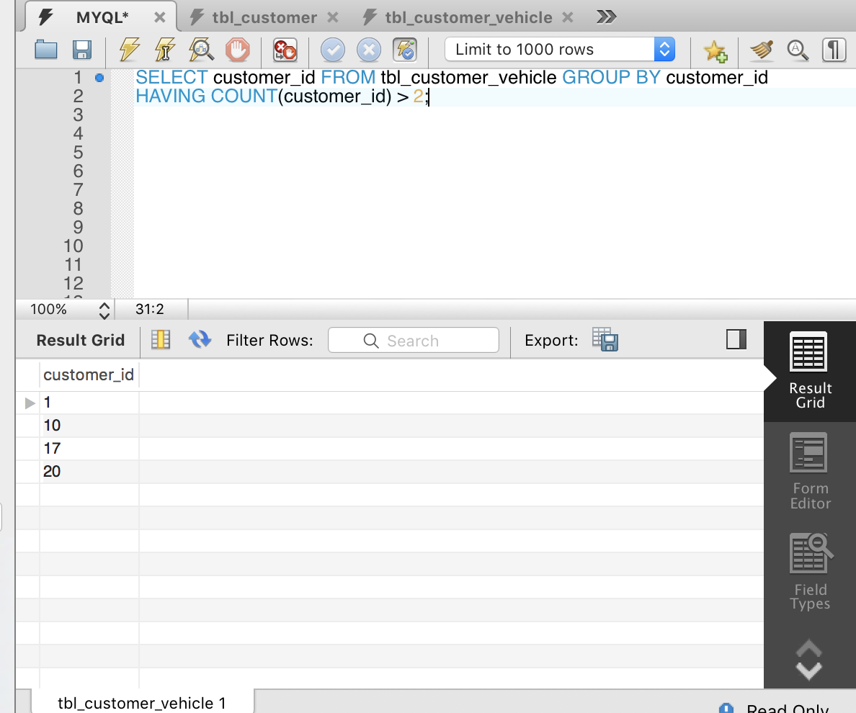

2)List the order id of orders and the number of services associated with thecorresponding order.

SELECT order_id, count(*) as Number_of_services from tbl_order_service

GROUP by order_id

HAVING

count(*) >= 1;

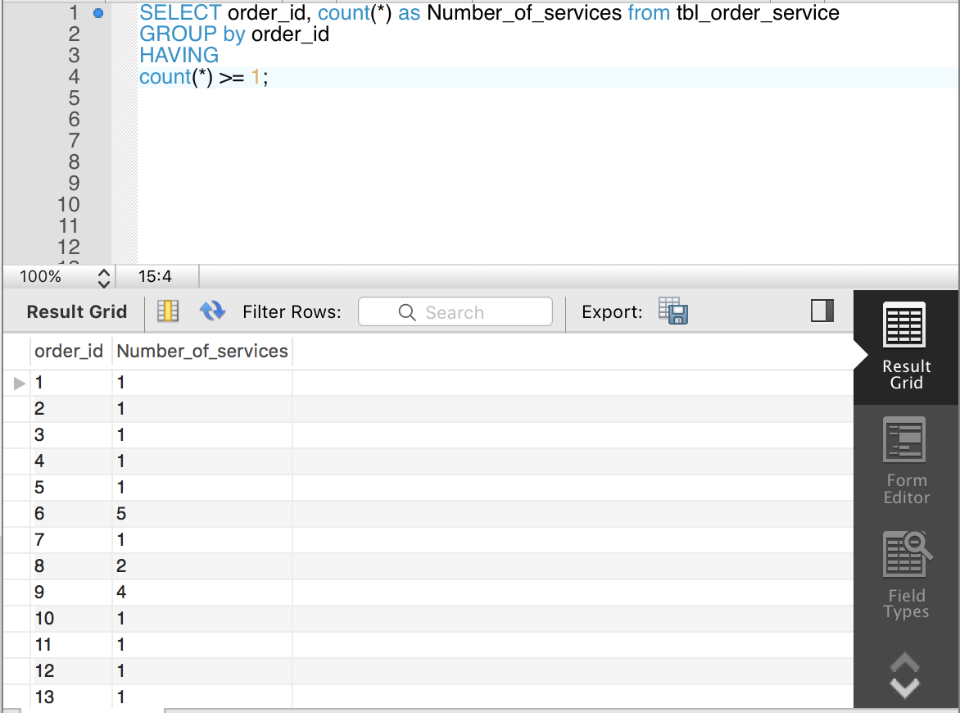

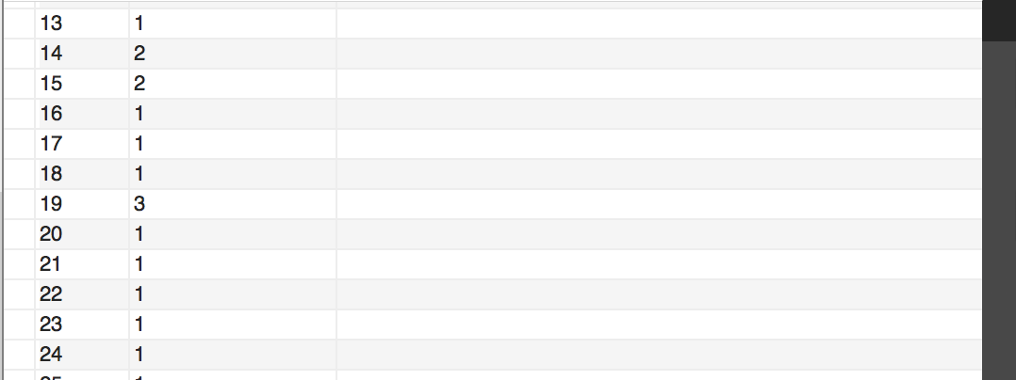

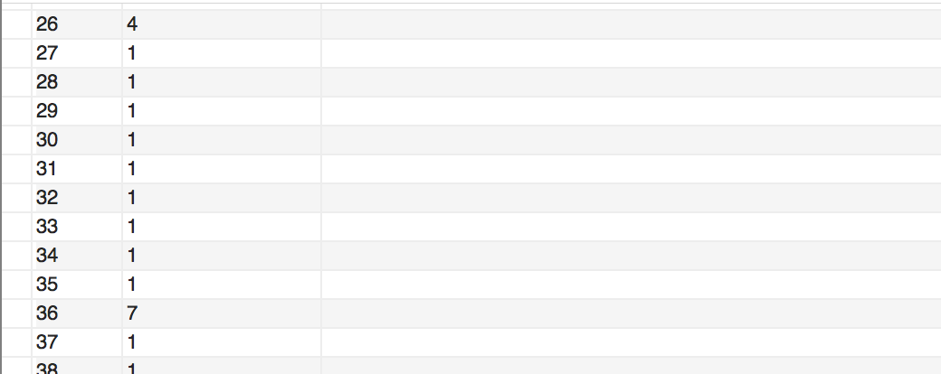

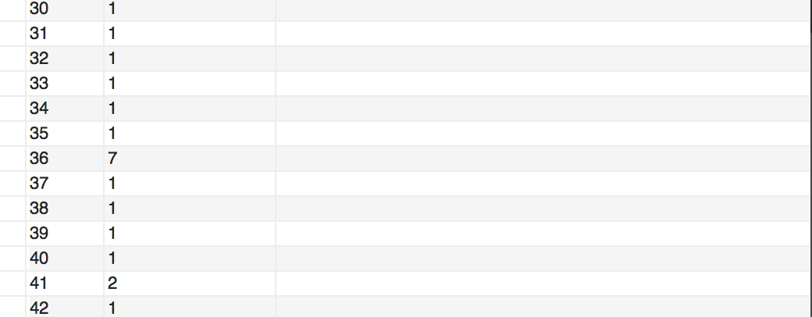

3)List the first name and the last name of customers who own more than 2 vehicles.

SELECT tbl_customer.first_name, tbl_customer.last_name FROM tbl_customer INNER JOIN tbl_customer_vehicle ON tbl_customer.customer_id = tbl_customer_vehicle.customer_id GROUP BY tbl_customer.customer_id

HAVING COUNT(tbl_customer_vehicle.customer_id) > 2;

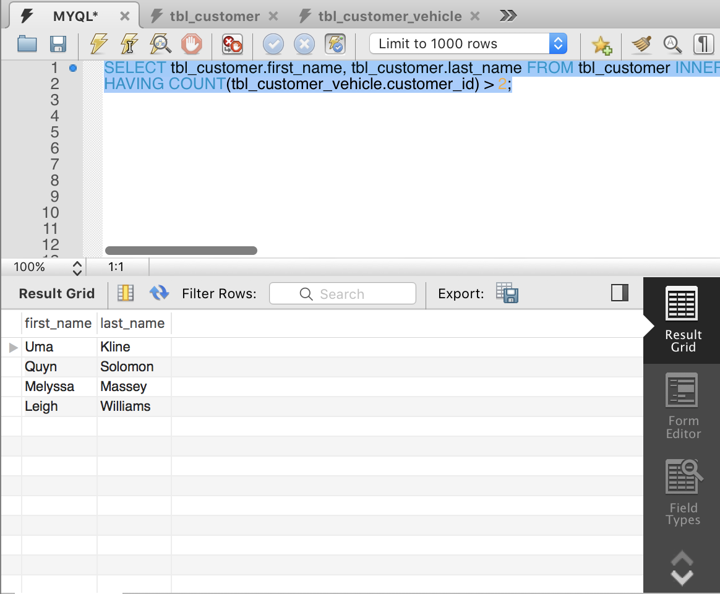

4)List the service id, name and cost of services whose costs are more than 500.

SELECT tbl_service.service_id,tbl_service.name,tbl_service.labor_hour * tbl_rate.labor_cost_per_hour + tbl_service.part_cost as Cost FROM tbl_service INNER JOIN tbl_rate ON tbl_service.rate_id = tbl_rate.rate_id

WHERE tbl_service.labor_hour * tbl_rate.labor_cost_per_hour + tbl_service.part_cost > 500;

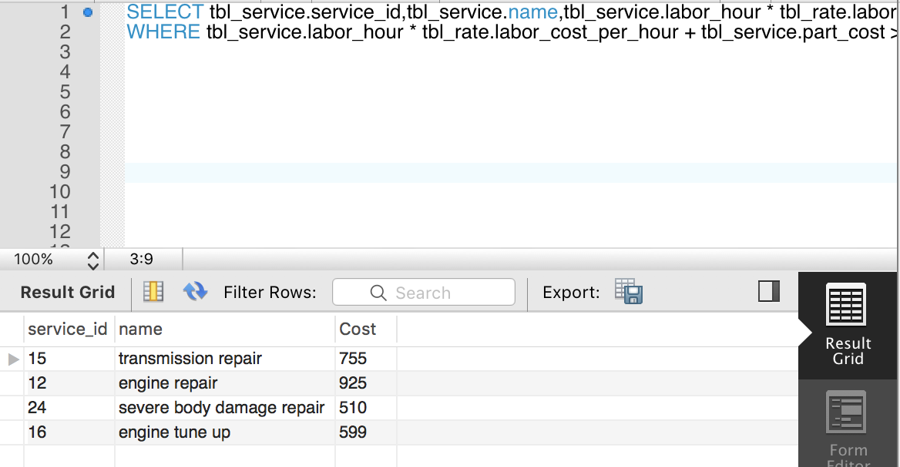

5)List the service id, name, number of service times and total income of each service.

SELECT service_id, name, labor_hour, (part_cost + labor_hour + labor_cost_per_hour) as totalincome from tbl_service

LEFT JOIN tbl_rate on tbl_rate.rate_id = tbl_service.rate_id

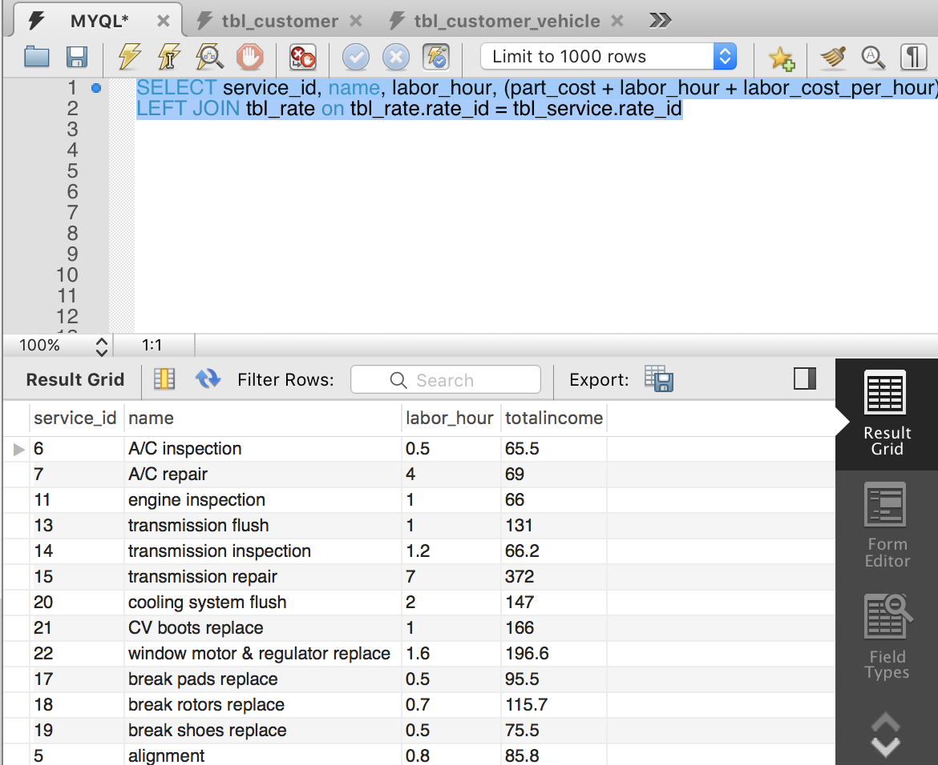

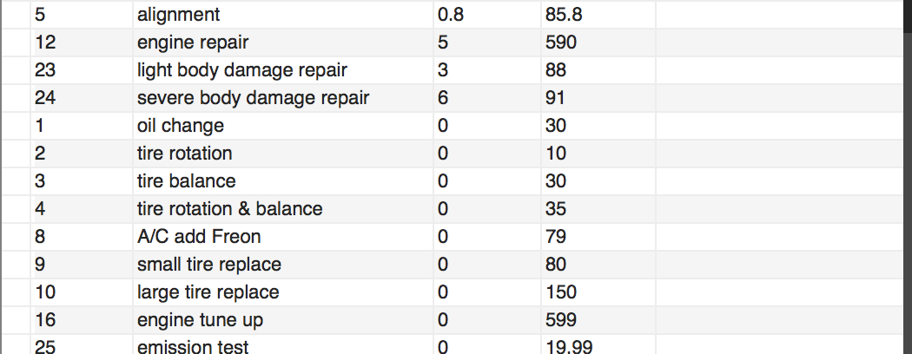

6)Which customer spent the most in this auto shop? List the first name, last name,customer id and total expense of the customer.

SELECT cust.first_name, cust.last_name, customercostsum.customer_id, customercostsum.costcount from

(

SELECT customer_id, sum(cost) as costcount

from

(

SELECT cu.customer_id,(part_cost+labor_hour*labor_cost_per_hour) as cost

from tbl_customer_vehicle as cu

LEFT JOIN tbl_vehicle_order as ve on ve.vehicle_id = cu.vehicle_id

LEFT JOIN tbl_order_service as ord on ord.order_id = ve.order_id

LEFT JOIN tbl_service as se on se.service_id = ord.service_id

LEFT JOIN tbl_rate as ra on ra.rate_id = se.rate_id

) as customercost

group by customer_id

) as customercostsum

LEFT JOIN tbl_customer as cust on cust.customer_id = customercostsum.customer_id

order by customercostsum.costcount desc

LIMIT 1

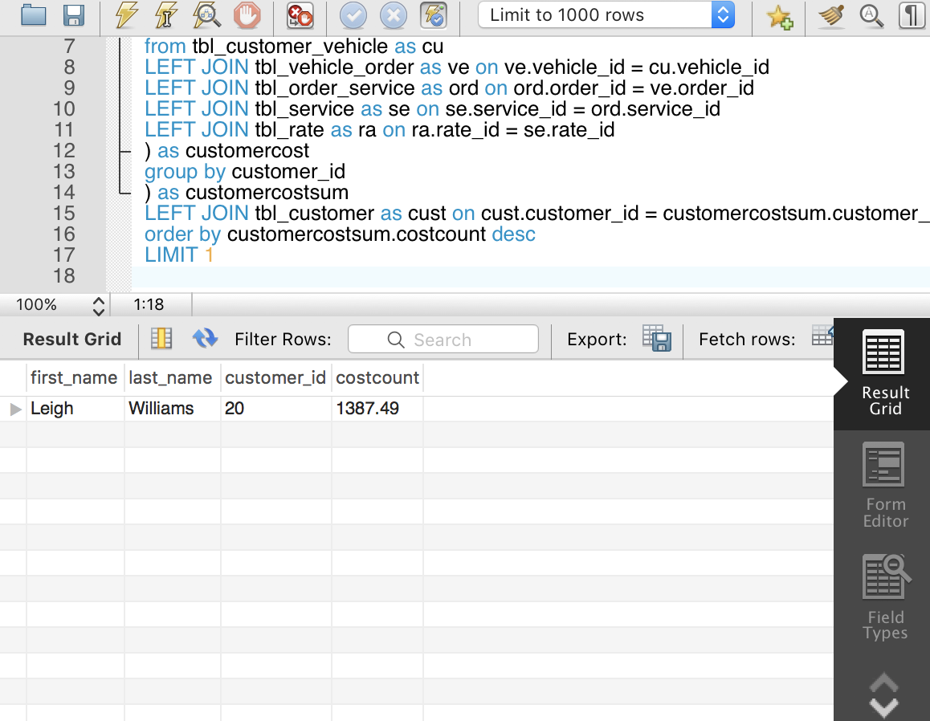

7)List the vehicle id, year, make, model, mileage, number of the associated orders and total spending cost of vehicles.

select ve.vehicle_id,ve.year,ve.make,ve.model,ve.mileage,vihicletotalcost.ordernumber,vihicletotalcost.vihiclecostsum

from

tbl_vehicle as ve

LEFT JOIN

(

SELECT vihicletotal.vehicle_id, COUNT(vihicletotal.order_id) as ordernumber,SUM(vihicletotal.cost) as vihiclecostsum

from

(

select veor.vehicle_id,veor.order_id,(part_cost+labor_hour*labor_cost_per_hour) as cost

from tbl_vehicle_order as veor

LEFT JOIN tbl_order_service as orse on orse.order_id=veor.order_id

LEFT JOIN tbl_service as se on se.service_id=orse.service_id

LEFT JOIN tbl_rate as ra on ra.rate_id=se.rate_id

) as vihicletotal

GROUP BY vihicletotal.vehicle_id

) as vihicletotalcost on vihicletotalcost.vehicle_id=ve.vehicle_id

